W301A-How to setup the AP mode?
Product line: Wireless Question category: Function configurations

Q: When do we need to configure AP mode for W301A?
A：Sometimes we have one wired router, and we want to access the Internet wirelessly on laptop, the AP mode of W301A can help you to achieve it.
The Connection Topology is as below:

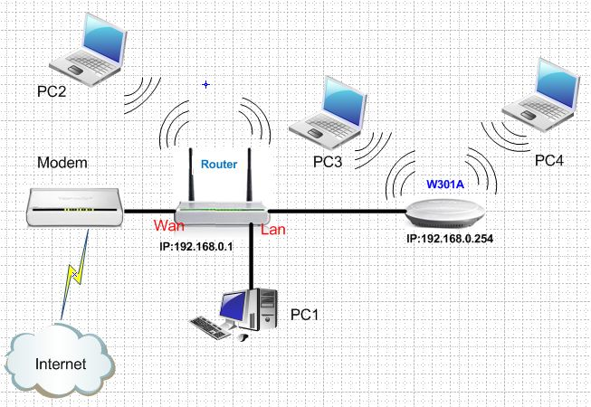

The Steps are as below:

1. Login to the homepage of W301A
2．After successfully logging, please click Setup Wizard to choose Wireless AP (AP) as the wireless working mode. And click Next.
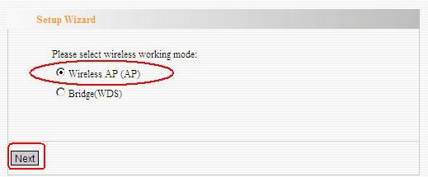

3．In the Basic settings page, change the SSID and select Channel 6 as the channel. And click Next.
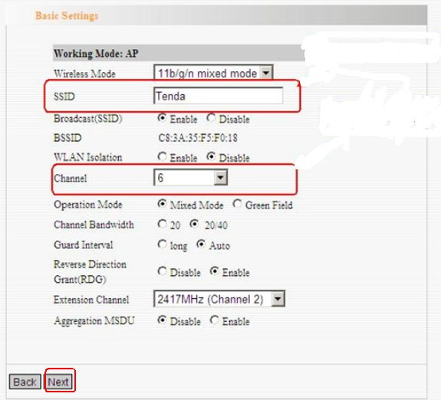

4．In the Security settings page, choose WPA-PSK as Security Mode and select AES as the WPA algorithms, then type a password for wireless network in the blank of Key and click Next.Then click Apply.
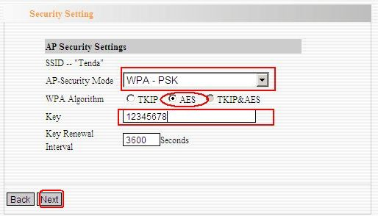
5．After you finish the above settings, please connect the W301A with the LAN port of uplink router by an Ethernet cable, and then the client computers can connect to the W301A wirelessly and get an IP address from the uplink wireless router.

